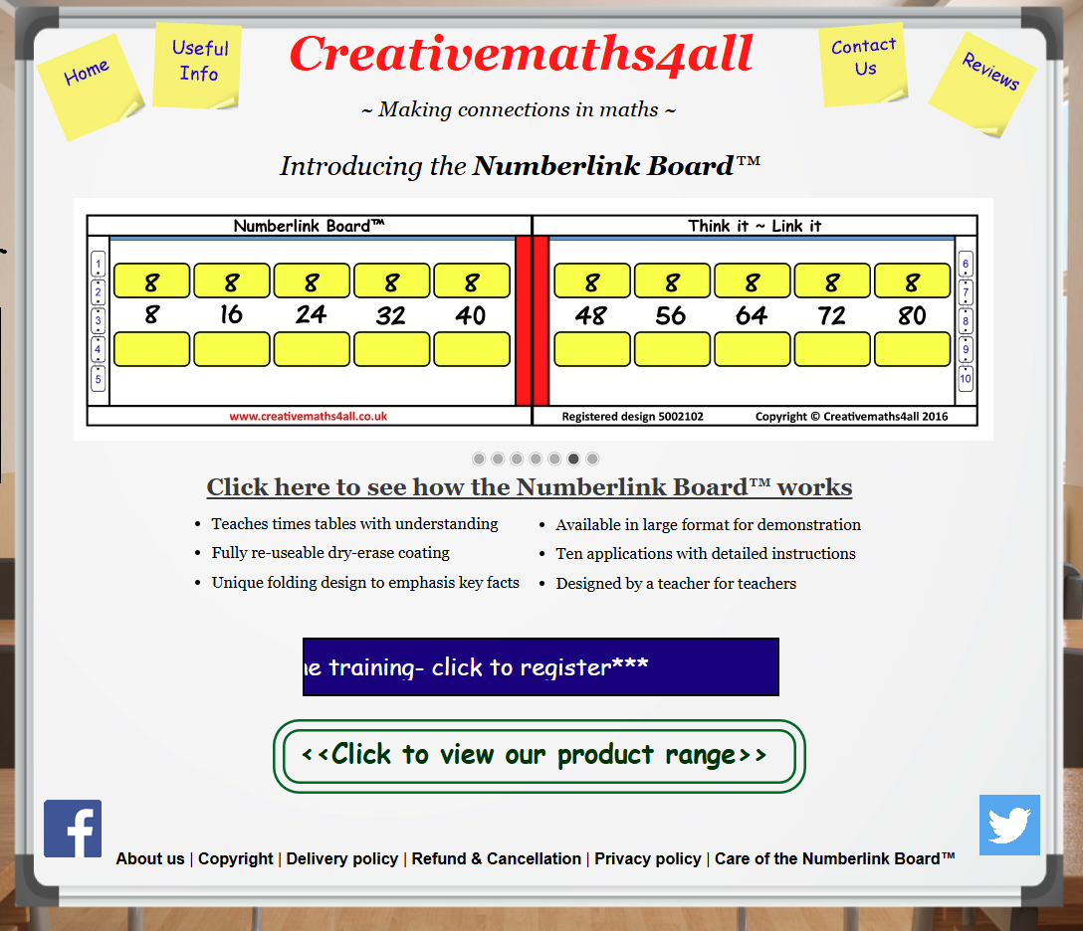

Training Video
https://www.facebook.com/NumberlinkBoard/videos/personalised-learning/1711348422463591/?locale=mt_MT

Number Link:
Also remember TT Rockstars

