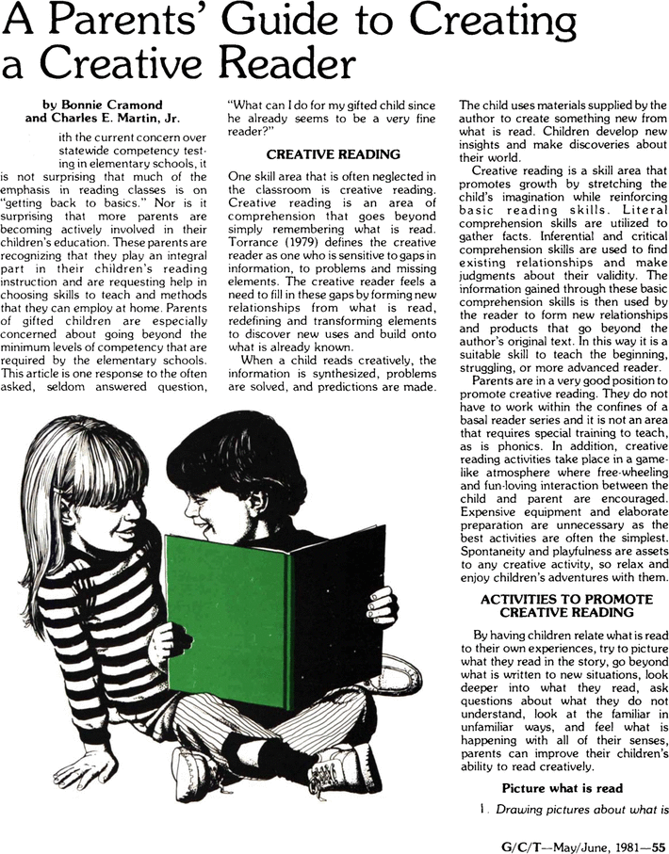

Primary English
https://primaryenglished.co.uk/blog/promoting-a-whole-school-love-of-reading

Articles and Studies

Developing boy’s love of reading
https://www.tandfonline.com/doi/abs/10.1080/09540253.2018.1533921

Understanding boys (dis)engagement with reading for pleasure: Project findings
https://oro.open.ac.uk/49310/

