

Here are the links for EEF key areas that we have been using and exploring within our CPD sessions.

https://educationendowmentfoundation.org.uk/education-evidence/teaching-learning-toolkit
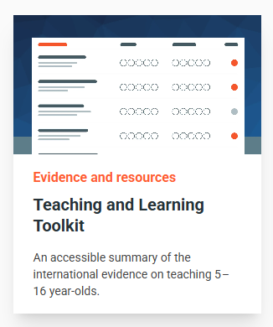

https://educationendowmentfoundation.org.uk/early-years/toolkit


