Lumi Nova: PARENT email / newsletter
For distribution to parents and guardians to introduce Lumi Nova, how to access and where to find more information.

Subject: Lumi Nova: Helping young people manage their worries
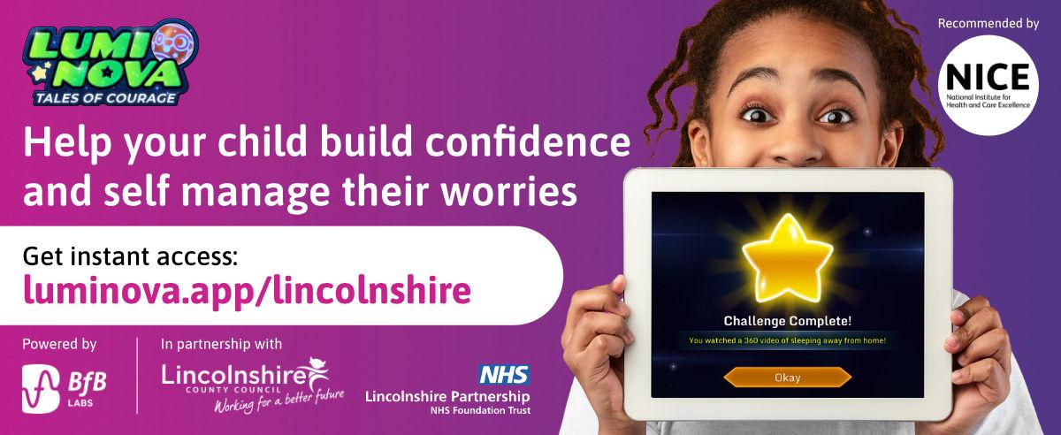
Dear parent / guardian,
We are delighted to share with you a new NHS funded service being piloted in Lincolnshire that’s designed to support young people aged 7-12 who are experiencing worries or anxieties; Lumi Nova.
What is Lumi Nova?
Lumi Nova is an intergalactic adventure game to support young people to fight fears and manage worries. Whilst exploring planets, customising characters and earning treasure your child breaks their fears and worries down into manageable steps, learning life-long skills and building resilience.
Watch this short animated video to learn more: Lumi Nova Introduction Video
Who can use Lumi Nova?
Lumi Nova was created for 7 - 12 year olds (school years 3 - 7) who are having difficulties with fears, worries, or anxiety related to social situations, separation or phobias.
Lumi Nova is ideal for children who may:
- lack confidence to try new things
- seem unable to face simple everyday challenges
- find it hard to concentrate
- have problems with sleeping or eating
- have angry outbursts
- have negative thoughts about what’s going to happen
- be avoiding everyday activities, eg. going to school, seeing friends
- become irritable, tearful or clingy
How do you access Lumi Nova?
Accessing Lumi Nova is quick and easy. Use the link below to register and you will receive a text message to guide you through getting started.
Luminova.app/lincolnshire
To find out more visit luminova.app or join a Parent Information Webinar.
Yours Sincerely

